1.

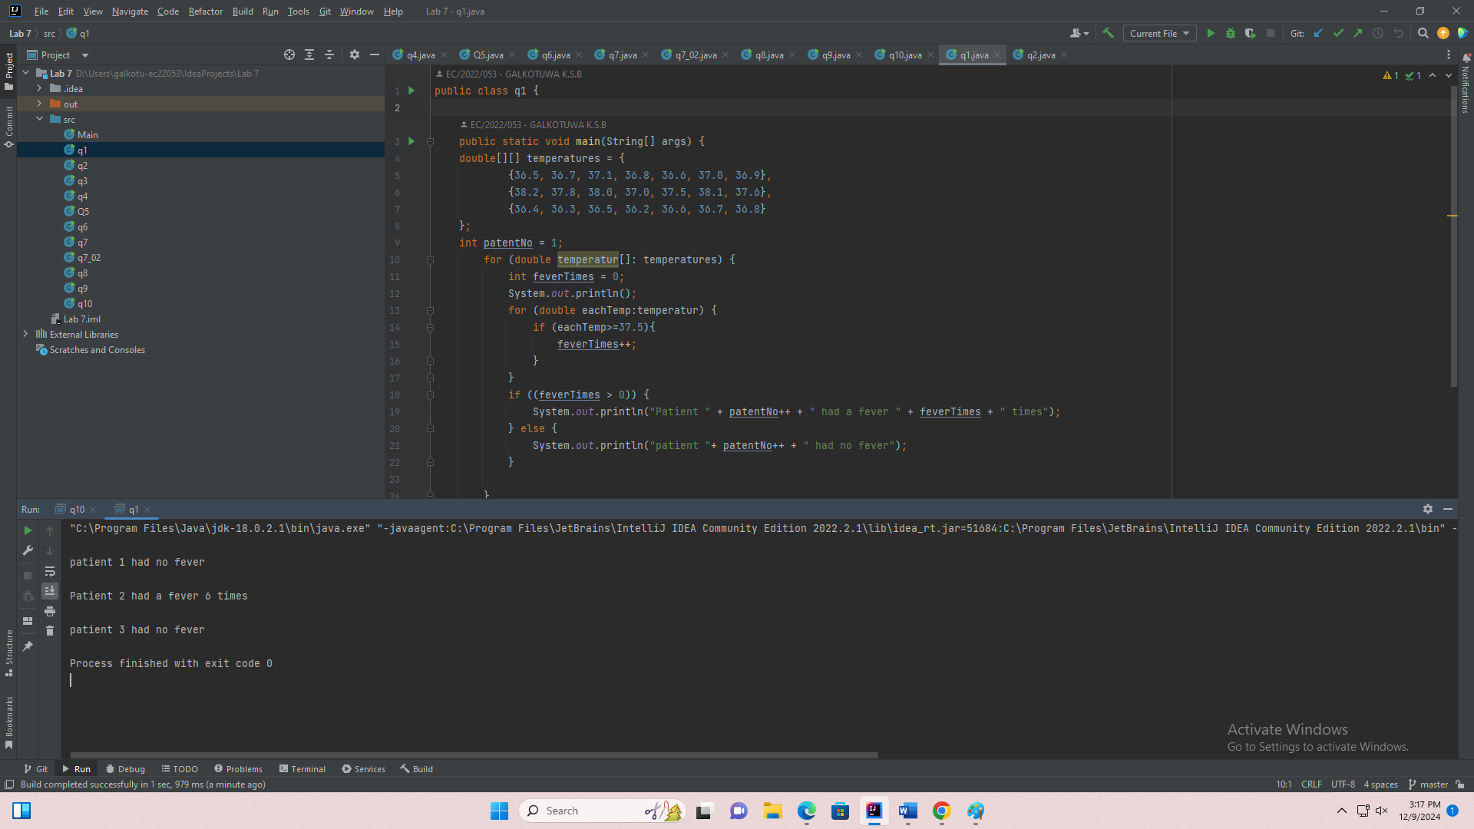

public class q1 {

public static void main(String[] args) {

double[][] temperatures = {

{36.5, 36.7, 37.1, 36.8, 36.6, 37.0, 36.9},

{38.2, 37.8, 38.0, 37.0, 37.5, 38.1, 37.6},

{36.4, 36.3, 36.5, 36.2, 36.6, 36.7, 36.8}

};

int patentNo = 1;

for (double temperatur[]: temperatures) {

int feverTimes = 0;

System.out.println();

for (double eachTemp:temperatur) {

if (eachTemp>=37.5){

feverTimes++;

}

}

if ((feverTimes > 0)) {

System.out.println("Patient " + patentNo++ + " had a fever " + feverTimes + " times");

} else {

System.out.println("patient "+ patentNo++ + " had no fever");

}

}

}

}

2.

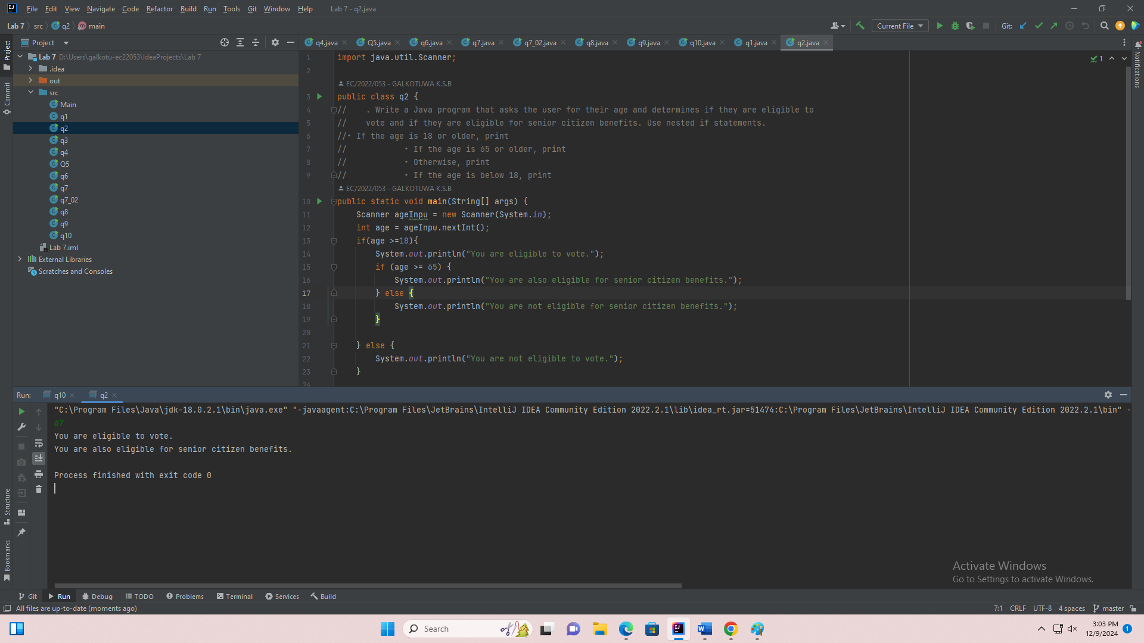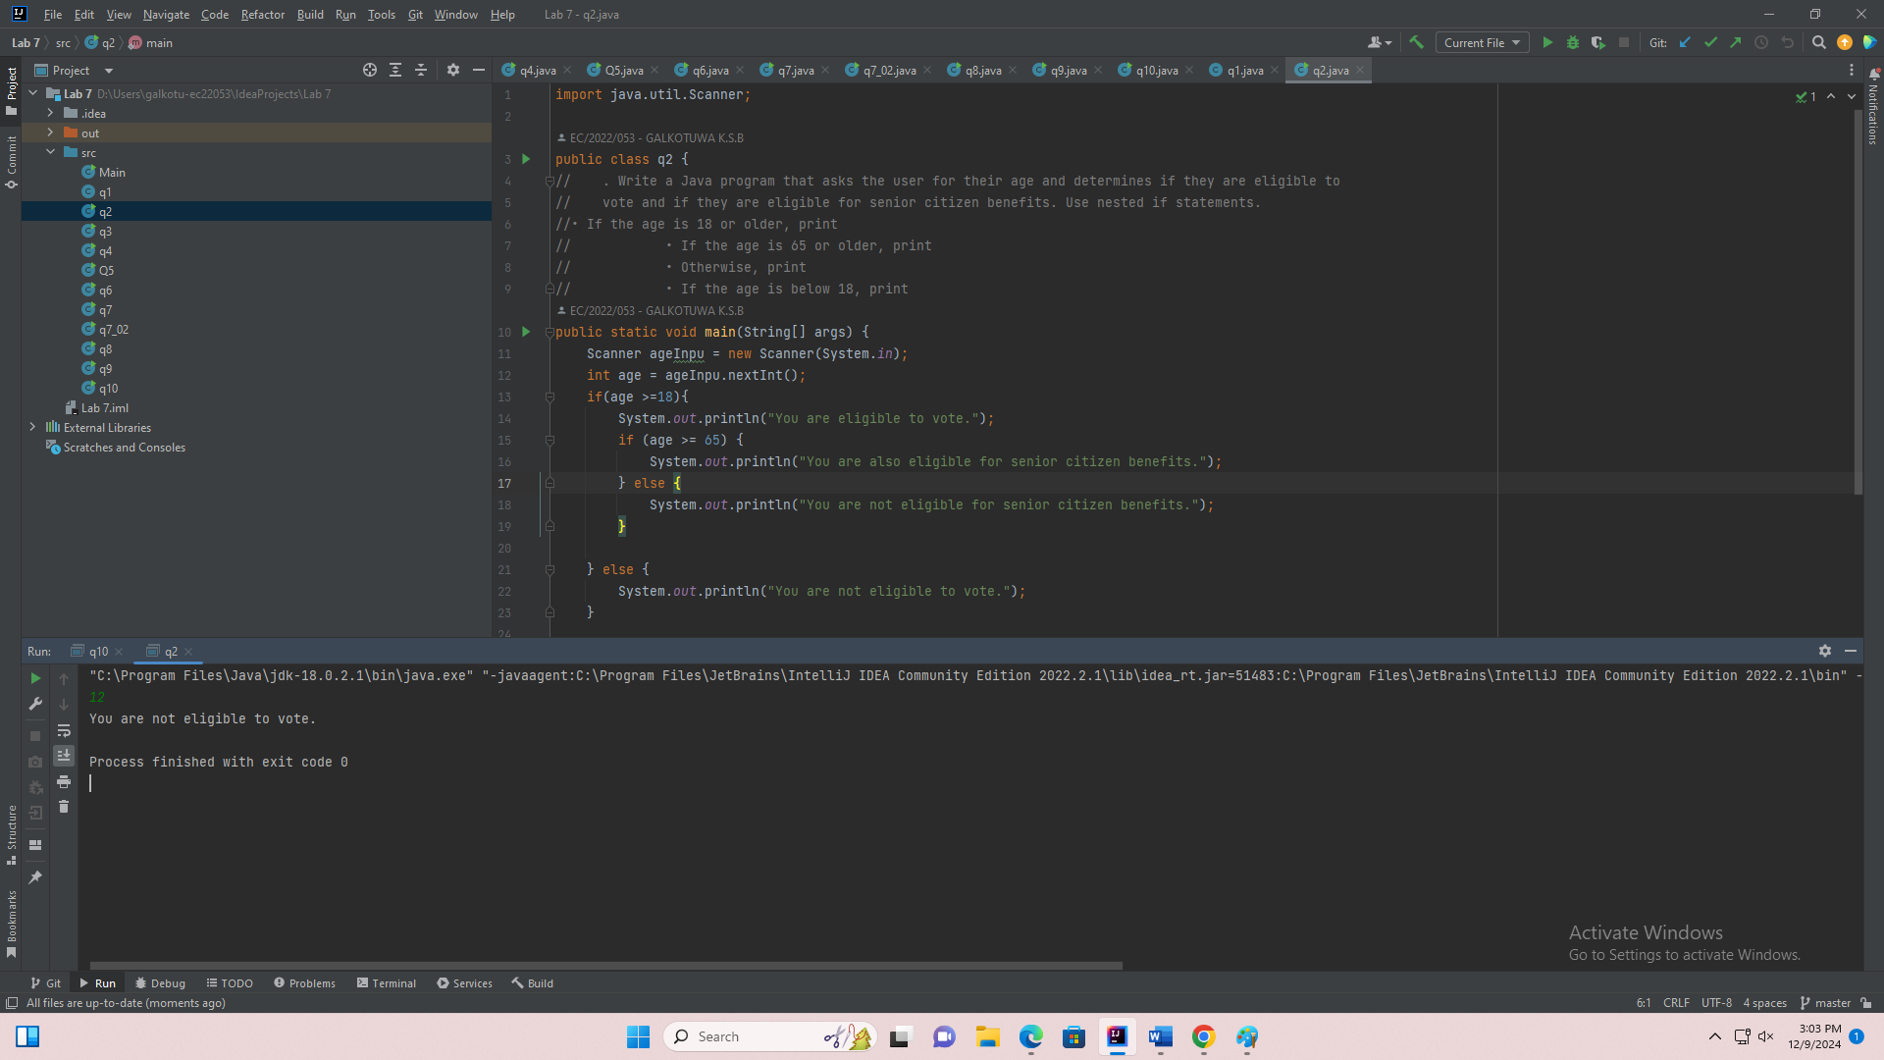

import java.util.Scanner;

public class q2 {

public static void main(String[] args) {

Scanner ageInpu = new Scanner(System.in);

System.out.print("Enter Age : ");

int age = ageInpu.nextInt();

if(age >=18){

System.out.println("You are eligible to vote.");

if (age >= 65) {

System.out.println("You are also eligible for senior citizen benefits.");

} else {

System.out.println("You are not eligible for senior citizen benefits.");

}

} else {

System.out.println("You are not eligible to vote.");

}

}

}

3.

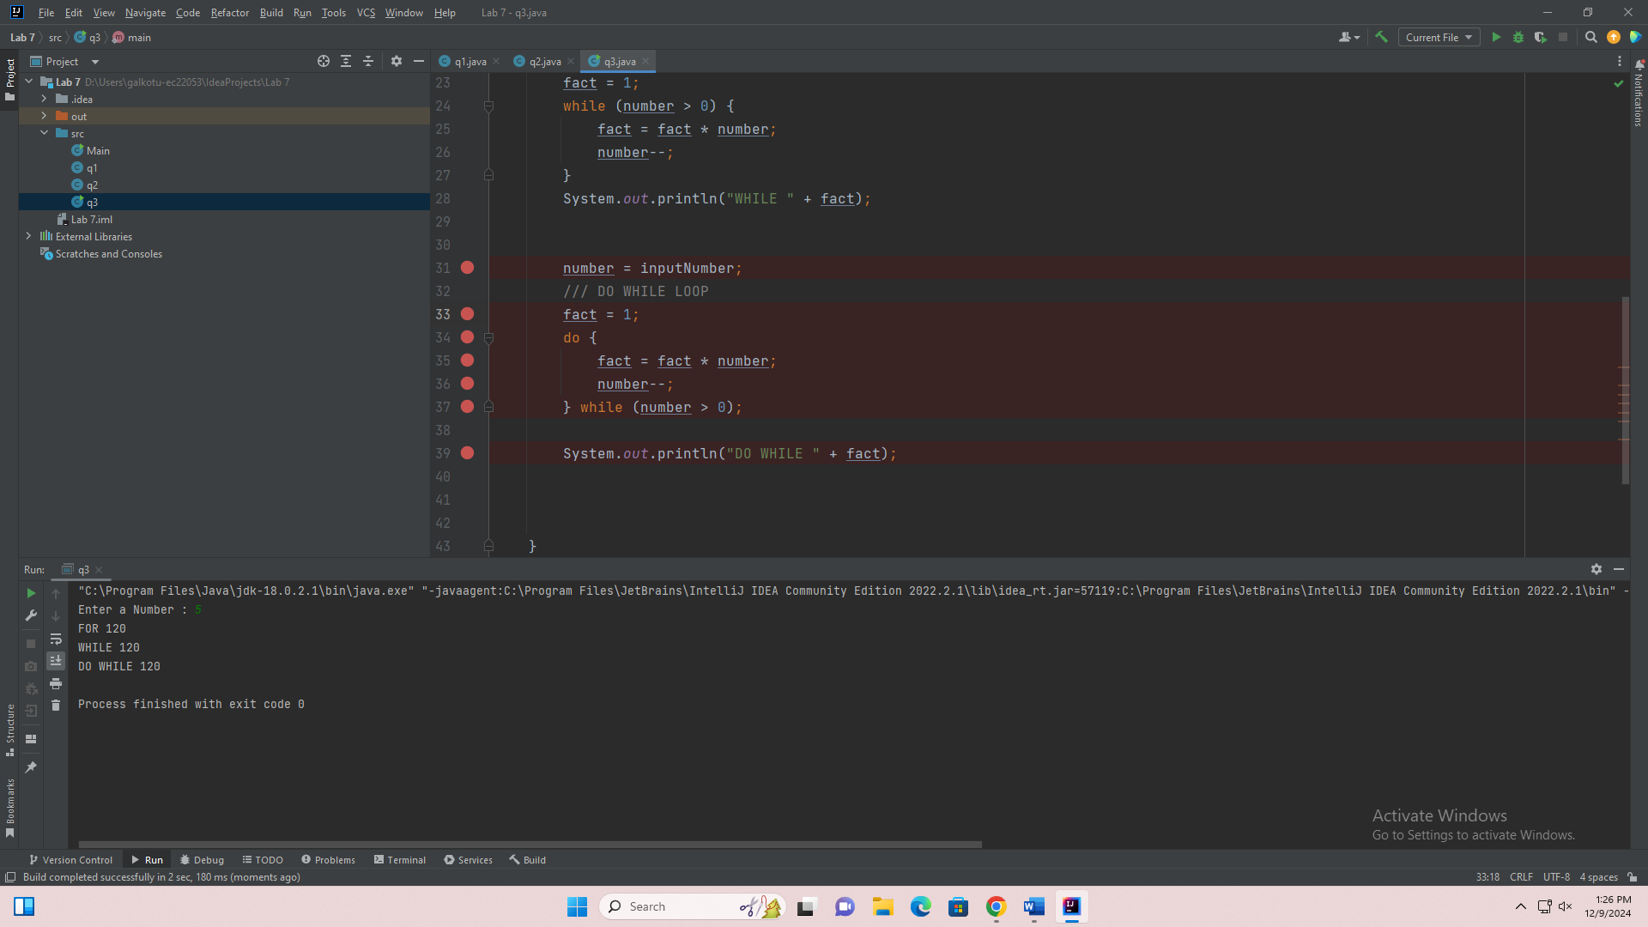

import java.util.Scanner;

public class q3 {

public static void main(String[] args) {

Scanner scanObj = new Scanner(System.in);

System.out.print("Enter a Number : ");

int number = scanObj.nextInt();

final int inputNumber = number;

///from for loop

int fact = 1;

for (int i = number; i >0 ; i--) {

fact = fact * i;

}

System.out.println("FOR " +fact);

/// WHILE LOOP

fact = 1;

while (number > 0) {

fact = fact * number;

number--;

}

System.out.println("WHILE " + fact);

number = inputNumber;

/// DO WHILE LOOP

fact = 1;

do {

fact = fact * number;

number--;

} while (number > 0);

System.out.println("DO WHILE " + fact);

}

}

4.

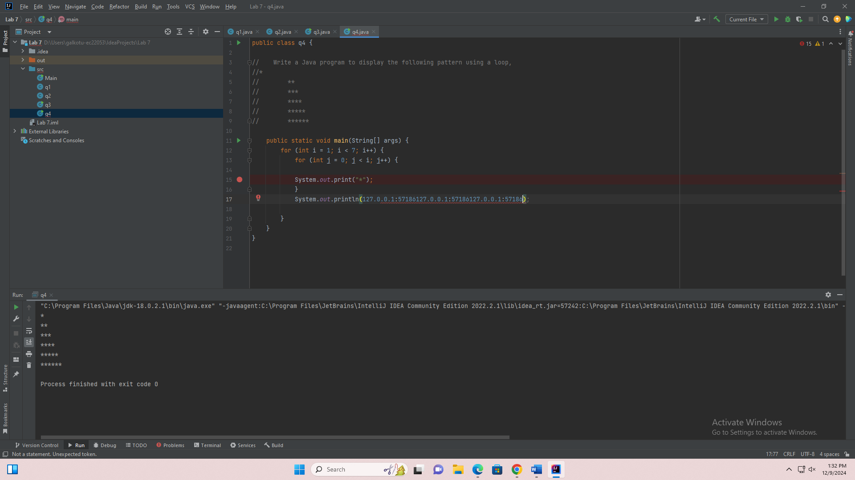

public class q4 {

public static void main(String[] args) {

for (int i = 1; i < 7; i++) {

for (int j = 0; j < i; j++) {

System.out.print("*");

}

System.out.println();

}

}

}

5.

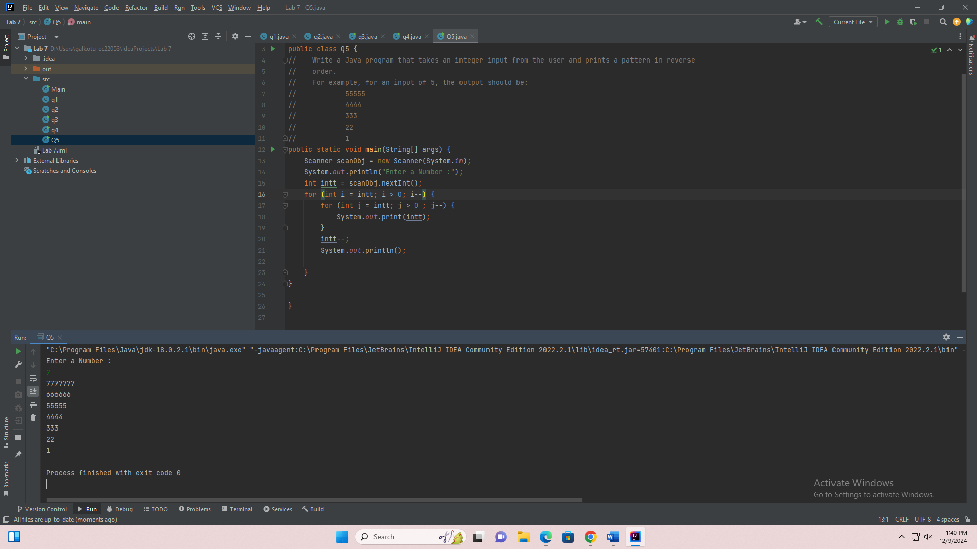

import java.util.Scanner;

public class Q5 {

public static void main(String[] args) {

Scanner scanObj = new Scanner(System.in);

System.out.println("Enter a Number :");

int intt = scanObj.nextInt();

for (int i = intt; i > 0; i--) {

for (int j = intt; j > 0 ; j--) {

System.out.print(intt);

}

intt--;

System.out.println();

}

}

}

6.

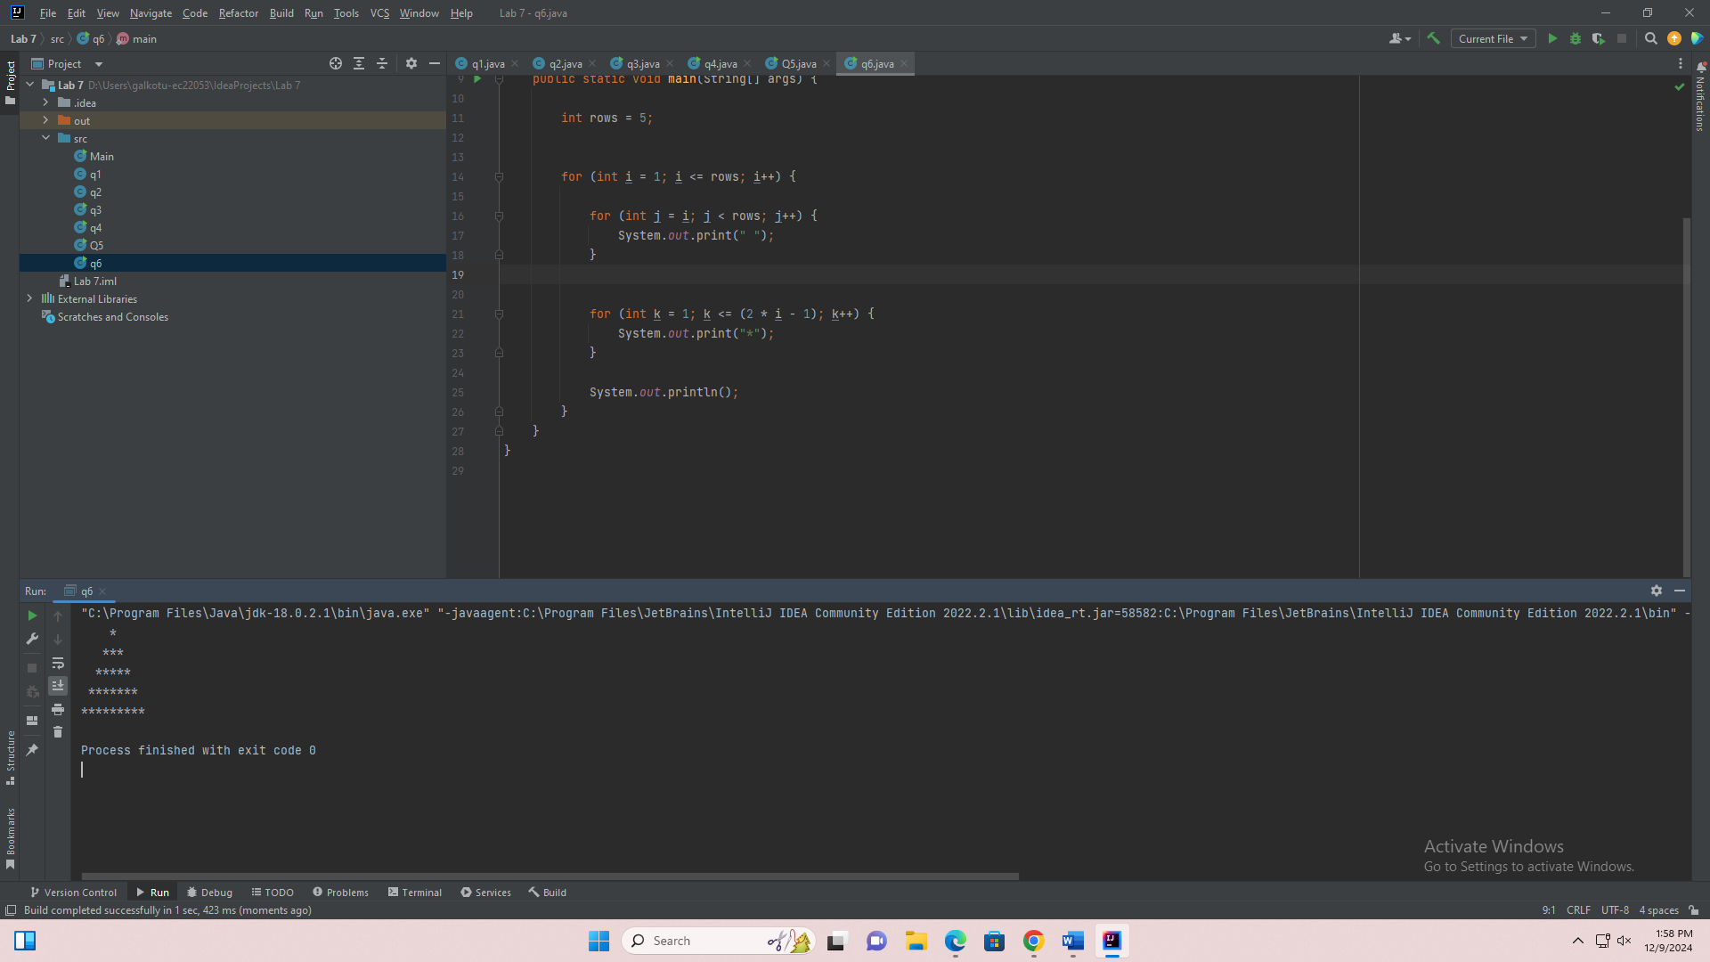

public class q6 {

public static void main(String[] args) {

int rows = 5;

for (int i = 1; i <= rows; i++) {

for (int j = i; j < rows; j++) {

System.out.print(" ");

}

for (int k = 1; k <= (2 * i - 1); k++) {

System.out.print("*");

}

System.out.println();

}

}

}

Q7.

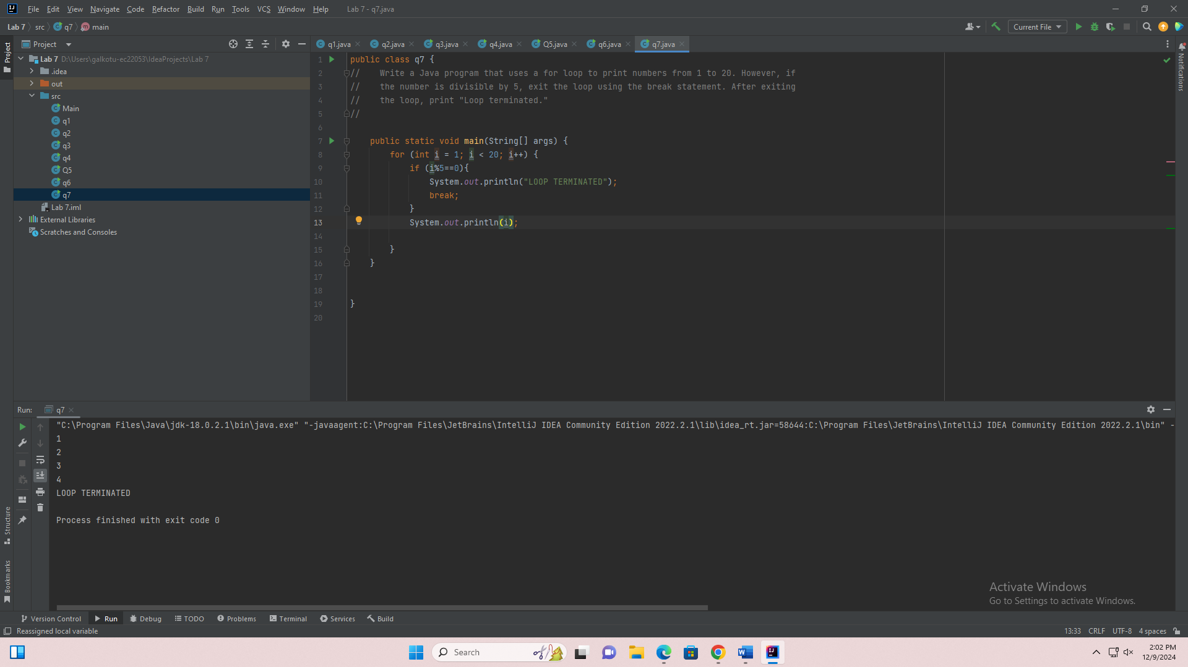

public class q7 {

public static void main(String[] args) {

for (int i = 1; i < 20; i++) {

if (i%5==0){

System.out.println("LOOP TERMINATED");

break;

}

System.out.println(i);

}

}

}

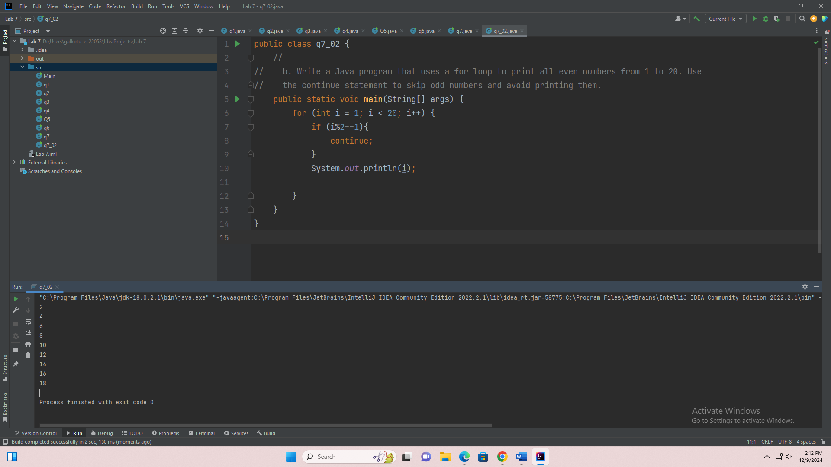

public class q7_02 {

public static void main(String[] args) {

for (int i = 1; i < 20; i++) {

if (i%2==1){

continue;

}

System.out.println(i);

}

}

}

Q8.

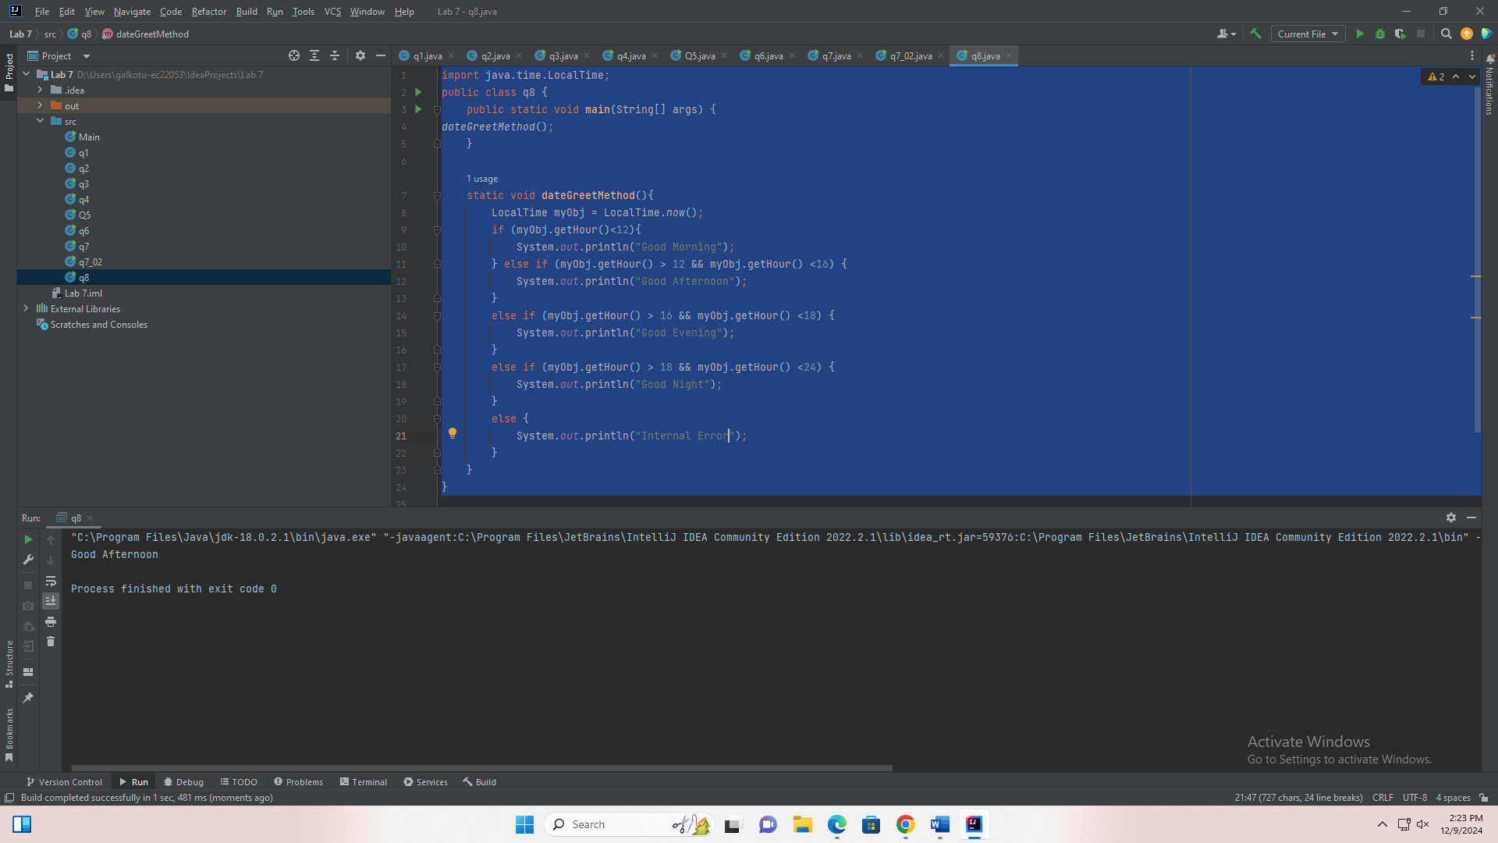

import java.time.LocalTime;

public class q8 {

public static void main(String[] args) {

dateGreetMethod();

}

static void dateGreetMethod(){

LocalTime myObj = LocalTime.now();

if (myObj.getHour()<12){

System.out.println("Good Morning");

} else if (myObj.getHour() > 12 && myObj.getHour() <16) {

System.out.println("Good Afternoon");

}

else if (myObj.getHour() > 16 && myObj.getHour() <18) {

System.out.println("Good Evening");

}

else if (myObj.getHour() > 18 && myObj.getHour() <24) {

System.out.println("Good Night");

}

else {

System.out.println("Internal Error");

}

}

}

9.

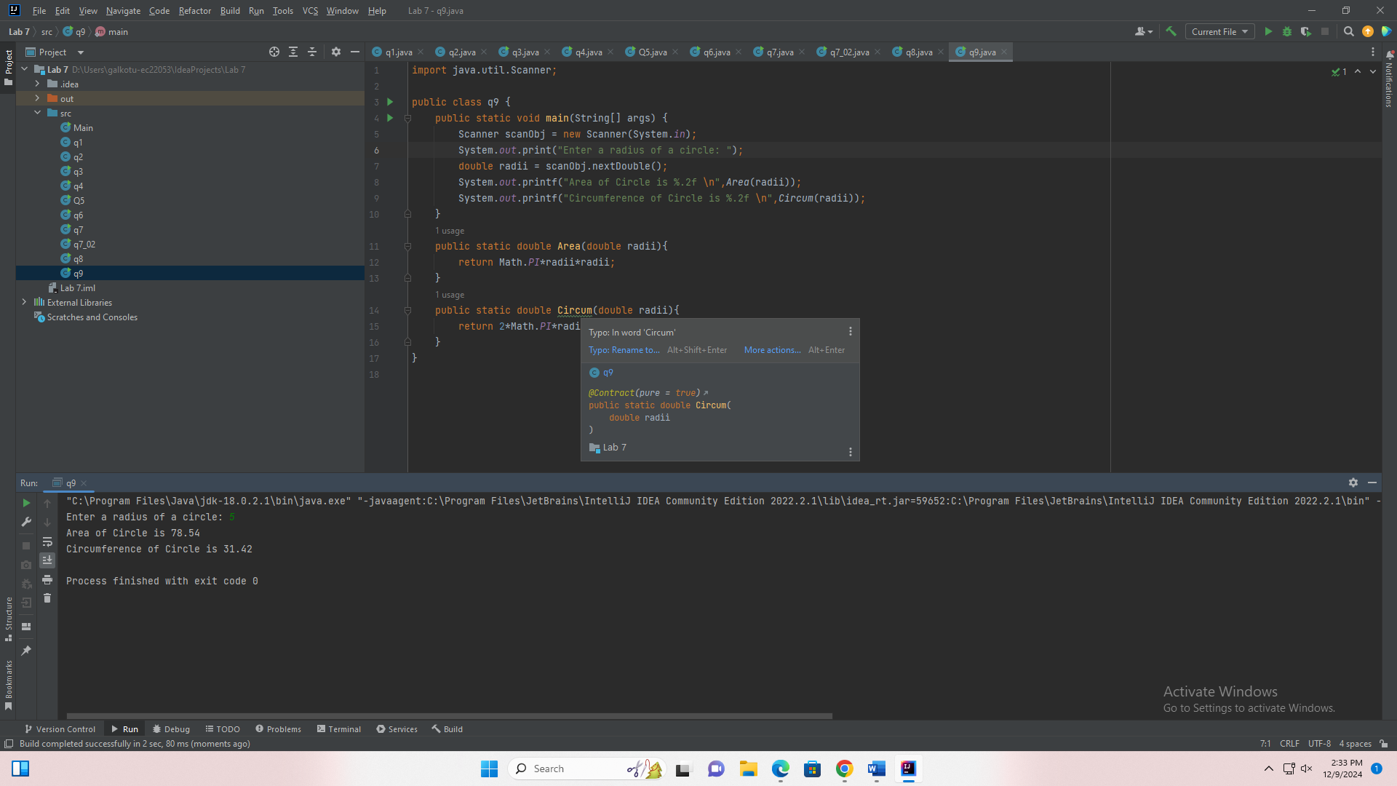

import java.util.Scanner;

public class q9 {

public static void main(String[] args) {

Scanner scanObj = new Scanner(System.in);

System.out.print("Enter a radius of a circle: ");

double radii = scanObj.nextDouble();

System.out.printf("Area of Circle is %.2f \n",Area(radii));

System.out.printf("Circumference of Circle is %.2f \n",Circum(radii));

}

public static double Area(double radii){

return Math.PI*radii*radii;

}

public static double Circum(double radii){

return 2*Math.PI*radii;

}

}

10.

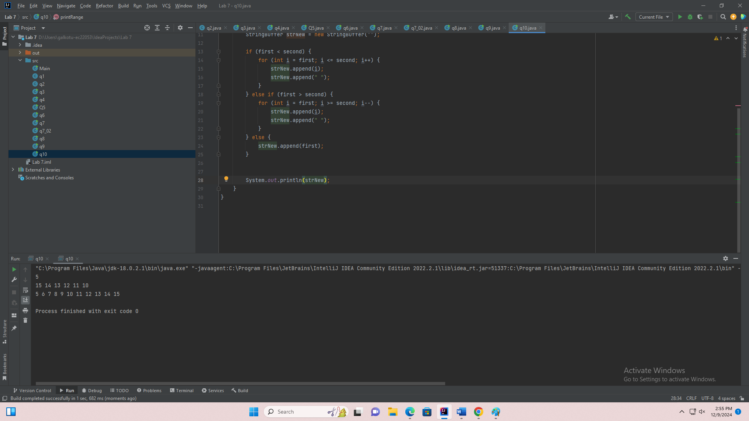

public class q10 {

public static void main(String[] args) {

printRange(5, 5);

printRange(15, 10);

printRange(5, 15);

}

public static void printRange(int first, int second){

StringBuffer strNew = new StringBuffer("");

if (first < second) {

for (int i = first; i <= second; i++) {

strNew.append(i);

strNew.append(" ");

}

} else if (first > second) {

for (int i = first; i >= second; i--) {

strNew.append(i);

strNew.append(" ");

}

} else {

strNew.append(first);

}

System.out.println(strNew);

}

}